- You Can't Judge A Book By Its Cover ( don't make judgments based only on appearances ... )
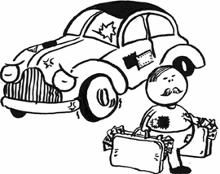
You can't judge a book by its cover means that before you can judge something, you need to take a deeper, closer look at it. Example: "He dresses in plain clothes and drives an old car. Who would know he is the richest man in town?" Reply: "You can't judge a book by its cover."
The value of something is not always obvious from what we see on the surface, so we should save our judgments until we have more experience. Example: "That professor may seem slow and awkward, but don't judge a book by its cover. He is one of the brightest minds in his field."
You can't judge a book by its cover means that when you have only seen the surface of something, you cannot know what is on the inside. Example: "Don't go falling in love with that girl so fast. Wait until you get to know her better. You can't judge a book by its cover."
- When Pigs Fly ( that thing will never happen ... )
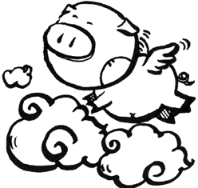
When pigs fly is an informal way to joke that you will never do something. Example: "Do you think you will ever work at that company again?" Reply: "When pigs fly!"
Pigs are heavy animals that stay close to the ground and do not fly, so when pigs fly is a time that will never come. Example: "Do you think your brother will be successful?" Reply: "When pigs fly he will."
When pigs fly is a time that will never come because pigs will never fly. Example: "Will you ever take her on a date?" Reply: "Sure: When pigs fly!"
- A Bird In The Hand Is Worth Two In The Bush ( keep what you have and don't be greedy for more ... )
A bird in the hand is worth two in the bush means that it is better to keep what you have than to give it up and try to get something better. Example: "Dan has asked me to go to a party with him. What if my boyfriend finds out? I don't know if I should go." Reply: "Don't go. A bird in the hand is worth two in the bush."
The thing that you already have is a bird in the hand; the things you want but don't have are two (birds) in the bush. You should not risk losing what you have by trying to get something that you don't have. Example: "I've been offered $250 for my stereo. Should I take it, or wait for a better offer?" Reply: "Take the $250. A bird in the hand is worth two in the bush."
A bird in the hand is worth two in the bush means that we should be happy with what we have and not risk losing it by being greedy and trying to get more.
- A Blessing In Disguise ( a good thing that you don't recognize at first ... )
"A blessing in disguise" is a good thing that you don't recognize at first as a good thing. Example: "The hotel is full tonight; we will need to find a new place to stay." Answer: "Maybe it's just a blessing in disguise; I've been wanting to try a new place anyway." Some people believe that good things are really "blessings" (gifts from God), that we don't always recognize for what they are at first. Example: "I lost my job and was upset at first, but I found a better one and have been much happier since." Answer: "Losing your job was just a blessing in disguise!" It is as if the good thing (a blessing) were wearing the clothes (in disguise) of some other thing, so at first you do not see it as the good thing that it really is. Example: "My car broke down again, but maybe it was a blessing in disguise; I've been wasting too much time driving around anyway."
- A Chip On Your Shoulder ( angry because of what happened in the past ... )
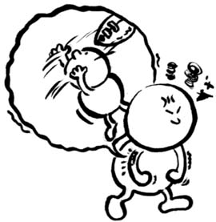
A person who has "a chip on his shoulder" is angry because of some thing that happened in the past. Example: "He lost his game this morning, and now he has a chip on his shoulder." It is easy for a person to get in a fight when he has a chip on his shoulder, because he is already angry about something else. Example: "Watch out for that guy, he's got a chip on his shoulder." To start a fight, men used to put chips of wood on their shoulder and challenge others to "try to knock it off". Example: "What's bothering that guy?" Reply: "Nothing. He's just got a chip on the shoulder." Example: "Tom had a tough time growing up, so he's got a bit of a chip on his shoulder." You can use the definite article ("the") which sounds more general ("a chip on the shoulder"), but more often people use the personal pronoun ("his", "her", "their") to say that that specific person has "a chip on his (her, their) shoulder."
- A Dime A Dozen ( cheap and easy to get ... )
If a thing is very common and easy to get, we say it is "a dime a dozen." Example: "Do you think I should buy this now and bring it with us?" Answer: "Don't bother; those are a dime a dozen where we are going." There is no need to get excited or worried about finding something that is a dime a dozen. Example: "Look what I found!" Answer: "That's nothing special; those are a dime a dozen." It is easy to find a dime (a 10 cent US coin), and a dozen (12) of something is a common, everyday unit of measure. You are not in a hurry to get a thing which is a dime a dozen because it is not so special and you could get one any time you wanted. Example: "I don't need friends like him; they are a dime a dozen."
- A Drop In The Bucket ( not important ... )
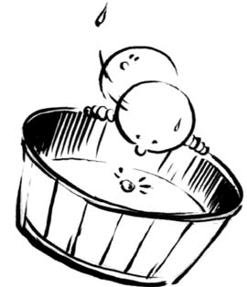
A drop in the bucket" is a something that is not important because it is very small. Example: "I'm sorry I scratched your car." Reply: "Don't worry about it. It's just a drop in the bucket. That car has more scratches on it than I can count." There are so many "drops" in a "bucket" of water that we could not count them all, so any one drop is really not that important. Example: "When I think how many people there are in the world, I realize that my own problems are just a drop in the bucket." "A drop" is very small amount when compared with all there is "in the bucket." "A drop in the bucket" is not important because it is a tiny amount when compared to the larger whole. Example: "I'd like to do something to change the world, but whatever I do seems like a drop in the bucket."
- A Fool And His Money Are Easily Parted ( foolish people lose money easily ... )
A "fool" is a person who is always joking and doing stupid things. "A fool and his money are easily parted" means that it is easy for a foolish person to lose his money. In this idiom it is "a" fool and "his" money that are easily parted. Example: "How is it that you left home with 20 dollars but you come home with nothing? A fool and his money are easily parted!" If you spend money carelessly and are cheated easily then you are a fool. "A fool and his money are easily parted" says that a foolish person ("a fool") is easily separated ("parted") from his money. Example: "Her husband can't seem to hold onto any amount of money; he either spends it or loses it. A fool and his money are easily parted."
- A Penny Saved Is A Penny Earned ( saving money is hard work and happens one penny at a time ... )
"A penny saved is a penny earned" means that little by little you will save money by not spending your money. Example: "I'm going to give you $20 but I want you to put it in the bank; a penny saved is a penny earned!" Not spending money has the same result as earning money, so to save a penny is the same as earning a penny. "A penny saved is a penny earned" compares saving money to earning money one penny at a time. Example: "My dad never lets me spend money on things I don't need. He always says a penny saved is a penny earned."
- A Piece Of Cake ( easy to do ... )
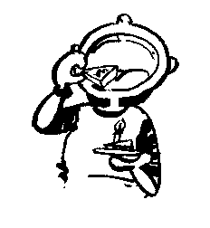
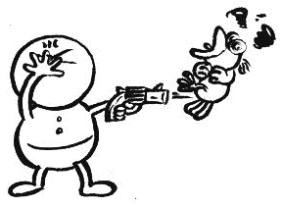
Something that is very easy to do is "a piece of cake". Example: "Can you finish your homework in ten minutes?" Reply: "It will be a piece of cake." "A piece of cake" is so easy to do that it is like eating a piece of cake. Example: "How was your test today?" Reply: "It was a piece of cake." You say "piece of cake" to show how very easy it is for you to do something. Example: "I've always had a hard time studying history, but math is a piece of cake." You are very confident that you can do something which you think is a piece of cake. Example: "Do you expect to win your tennis match today?" Reply: "It will be a piece of cake."
- A Shot In The Dark ( a guess when you don't know the facts ... )
A shot in the dark is a guess at the answer to a question when you do not feel that you know the facts. Example: "How did you know I was from America?" Reply: "Just a shot in the dark."
To take a shot is to guess at the answer. You are in the dark when you are not clear about the facts. You take a shot in the dark when you try to guess the answer to a question but you are not sure of the facts. Example: "That was a tough question. How did you get it right?" Reply: "I just took a shot in the dark."
When people do not know how to answer a question, you can encourage them to guess anyway, taking a shot in the dark. Example: "How old do you think I am?" Reply: "I have no idea." Answer: "Really, come on. Take a shot in the dark."
- A Slap On The Wrist ( a slight punishment ... )
A slap on the wrist is a punishment that is very mild. Example: "He should be in jail for what he did, but he got off with just a slap on the wrist."
When the punishment turns out to be less than was expected, it is considered a slap on the wrist. Example: "You got off easy this time, but stealing is a serious crime and next time it won't just be a slap on the wrist."
A slap on the wrist is a light, almost gentle punishment for doing something wrong. Example: "The police have gotten very serious about prosecuting drunk drivers. Nowadays you don't just get a slap on the wrist; they will throw you in jail."
- A Slip Of The Tongue ( to say something by accident ... )
When you say something by accident - something which you did not mean to say - you have made a slip of the tongue. Example: "I didn't mean to say that! It was just a slip of the tongue." When you are walking and one of your feet slip, you lose your footing and sometimes you fall down; when you make a slip of the tongue, you misstep with your words (the tongue) and say something that you did not plan to say. Example: "Be careful talking to the police tomorrow; one slip of the tongue could get us into big trouble." Sometimes a slip of the tongue causes you a problem because you have said the wrong thing at the wrong time.
- A Taste Of Your Own Medicine ( a lesson where other people treat you the same way you treat them in order to teach you that you are acting badly ... )
Someone gives you "a taste of your own medicine" when they act towards you the same way you act towards others in order to teach you a lesson about the way you are acting. If a man acts rudely to others, for example, acting rudely back to him would be giving him "a taste of his own medicine." Example: "Did you see those two people cutting in front of us in line just now? Let's cut in front of them and give them a taste of their own medicine!" Most "medicine" does not taste good; "your own medicine" is the way you act towards other people; you get "a taste of your own medicine" when you "taste" what it feels like for others to haveyou act towards them the way you do. Example (this is aggressive): "I saw you pushing my brother yesterday... maybe I should give you a taste of your own medicine!" It is like medicine because you think it is good for the other person to learn that they are treating others unfairly, even if the lesson does not taste good. Example: "He's always interrupting people when they are talking; what he deserves is a taste of his own medicine!" Example: "It looks like she got a taste of her own medicine."
- A Toss-Up ( the results have not been decided ... )
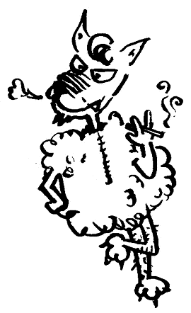
When something is a "toss-up", we are not sure what the result will be. The analogy is to tossing a coin as a way of making a decision. When "flipping" (or "tossing") a coin there is a 50 percent chance that the toss will end up one way and a 50 percent chance that the toss will end up another way. When something is very close and we can't tell if it should be one way or the other, we say that it is a toss-up.
- A Wolf In Sheep's Clothing ( one who is dangerous while pretending to be harmless ... )
"A wolf in sheep's clothing" is a dangerous person pretending to be harmless. Example: "I want you to stay away from that boy. He's a wolf in sheep's clothing." "A wolf in sheep's clothing" is a person who plans to do something bad ("a wolf") while pretending to be good and innocent ("in sheep's clothing"). Example: "I do not trust the salespeople at that store. They are all wolves in sheep's clothing." In past times wolves had a reputation as wild and dangerous animals that hunted and killed sheep. "A wolf in sheep's clothing" is a very dangerous wolf because we do not prepare ourselves for the attack. Example: "She may look cute, but that girl is a wolf in sheep's clothing."
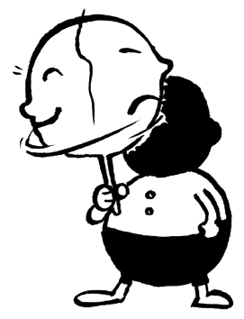
- An About Face ( turn around and face the opposite direction ... )
You do "an about face" when you begin facing one direction, then you turn completely to face in the opposite direction. Example: "If you ever discover that you are walking down a dangerous street, it is best to do an about face and walk in the other direction." You "do an about face" when you stand facing north, for example, then turn your body in one step until you face south. The term "about face!" is used in the military: The drill sergeant shouts "About face!" and all of the soldiers turn in one step to face the opposite direction. Example: "I want you to do an about face, get back in that bathroom, and brush your teeth!" To "do an about face" is also to change your position on something and take the opposite position.
- Absence Makes The Heart Grow Fonder ( the time spent apart makes you care for a person even more ... )
"Absence makes the heart grow fonder" means that the time you spend away from one you love makes you love that person even more. Example: "Does it bother you that your husband goes away on long business trips?" Reply: "No. The time we have spent apart has been good for us. Absence makes the heart grow fonder." The word "absence" means to be away. To "grow fonder" is to care more. "Absence makes the heart grow fonder" means the time you spend away from someone you love ("absence") makes you love that person even more ("the heart grows fonder"). Example: "It is much easier to get along with your parents when you live away from home. You miss them so much and are glad when you see them." Reply: "It's true. Absence makes the heart grow fonder." When someone you care for is away, you miss that person and think about them often, and that feeling makes you want to be with them even more.
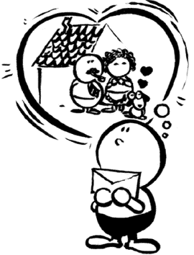
- Actions Speak Louder Than Words ( we learn more from people's actions than from their words ... )
"Actions speak louder than words" means that your actions (what you do) communicate more clearly than your words (what you say). It is as if they were louder than words. "Actions speak louder than words" means that if you want people to believe your words, you should "speak" with your actions. Example: "Don't tell me how to do this; show me! Actions speak louder than words."
- Add Fuel To The Fire ( do something to make a bad situation worse ... )
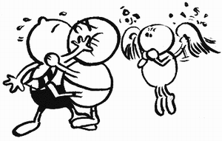
You add fuel to the fire when you do something that makes a bad situation worse. Example: "When those two are fighting, I don't get involved. It only adds fuel to the fire."
A conflict between two people is like a fire, with both people adding "fuel" to the fire. You add fuel to the fire when you do something that makes the conflict worse. Example: "I wanted to help, but I was afraid I would add fuel to the fire."
Adding "fuel" (such as wood or gas) to a burning "fire" makes the flames burn even higher and brighter. Sometimes you get involved because you want to help, but your involvement only makes the problem worse, adding fuel to the fire. Example: "Please don't talk to him when he's in a bad mood. It just adds fuel to the fire."
- Against The Clock ( working hard to finish by a certain time ... )
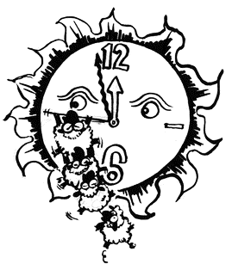
You are working against the clock when you are trying to finish your work within a limited amount of time. Example: "We worked against the clock all day to get that report done by five."
You often compare the time on the clock against how much work you have left to do when you are working against the clock. Example: "We have to finish this report by 8 o'clock tonight, so we're really working against the clock."
The passing of time ("the clock") works against you when you are working against the clock. Example: "Mom, will you have time to help me with my homework today?" Reply: "Sorry, I won't. I'll be working against the clock to finish my presentation."

